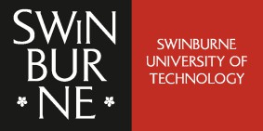
ICT80004 Final Internship Project Review Form - Close

To be submitted to Canvas by week 13.
Student Name: Arun Ragavendhar Arunachalam Palaniyappan

ID: 104837257

Organisation: Commonwealth Scientific and Industrial Research Organisation (CSIRO)

Industry Supervisor:
Dr. Shigang Liu
Date: 22/10/2025

Rate your current level of knowledge on the following by ticking on the appropriate box. (Complete this in consultation with your industry supervisor)

Your perception  Knowledge | I can teach and share this to my  colleagues | I know more than enough | I’m happy with what I know | I want to learn more about this | I like to have help on this
1. awareness of a range of issues  associated with professional practice |  |  |  |  | 
2. professional and personal skills |  |  |  |  | 
3. practical skills and theoretical  knowledge into an IT industry context |  |  |  |  | 
4. understanding of business processes  and organisational structures |  |  |  |  | 
5. professional contacts and networks  within the IT industry |  |  |  |  | 

Student’s Comments:

Over this internship with CSIRO’s Data61, I moved from research to repeatable practice. I designed and ran three streams of work: (1) Code safety—a small C program that shows a bad run vs a fixed run for memory safety; I also tested 12 common bug types with 4 ways of prompting to see what fails and what fixes it. (2) Text prompts—a 325-prompt set (direct and re-worded) across nine tactics, placed at the start, middle, and end of a message; a simple R check keeps the sheet clean by catching duplicates, very similar items, and mismatched decisions so comparisons are fair. (3) Pattern tests (FPA)—small changes to familiar examples that reveal when a model “assumes” a path ran while the program shows it didn’t. All outputs—logs, screenshots, tables, and demo code—are reproducible and saved in a shared repository. This strengthened my professional practice (clear methods, documented evidence, weekly updates), sharpened my technical skills (experiment design, data quality checks, safe-coding rules), and linked classroom theory to an industry problem and workflow. I also learned where to grow next: set scope earlier and share more hands-on tasks with teammates to create extra learning opportunities. Overall, I can now explain risks plainly, show proof others can re-run, and recommend simple steps teams can adopt right away—directly meeting the unit learning outcomes on professional practice, skills growth, industry application, process awareness, and networks.

Industry Supervisor’s Comments:
Arun has shown strong dedication, curiosity, and technical skill throughout the internship at CSIRO’s Data61. He worked hard, learned quickly, and successfully completed all assigned tasks with high quality and professionalism. His work on code safety, structured prompt evaluation, and pattern testing was systematic, reproducible, and well documented. He demonstrated the ability to connect theoretical understanding with practical application, communicate results clearly, and work independently. Overall, he performed exceptionally well, showing excellent growth and strong potential for future research or industry roles.

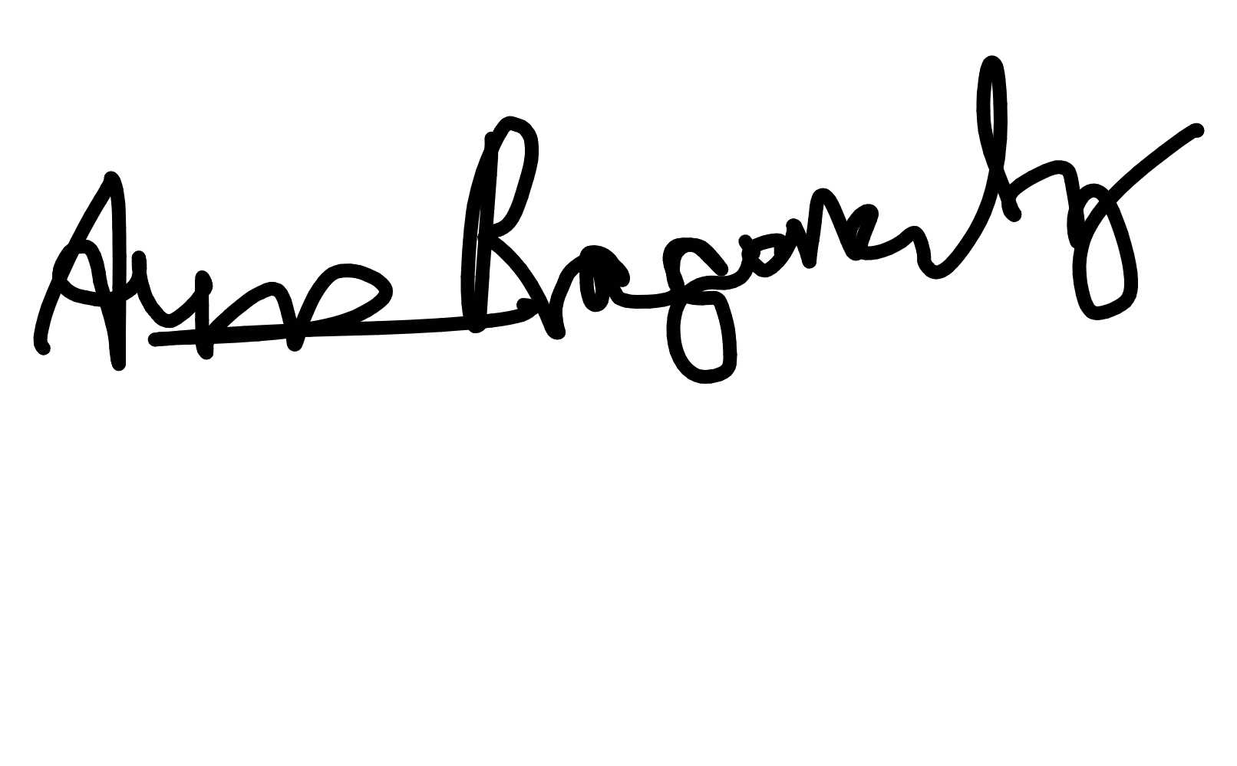
Student Signature: Date:
Digitally signed by e6946984- aaa8-4280-8911-ef2eebc1142c Date: 2025.10.22 09:57:16 +11'00'

Supervisor Signature: Date:
Shigang Liu
Digitally signed by Shigang Liu Date: 2025.10.22 14:03:15
+11'00'
22/10/2025

22/10/2025

ICT80004 – Final Internship Project Review Form

